9th Annual Power of the Purse Brunch Event
Saturday, April 6, 2024

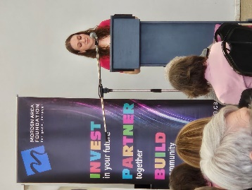
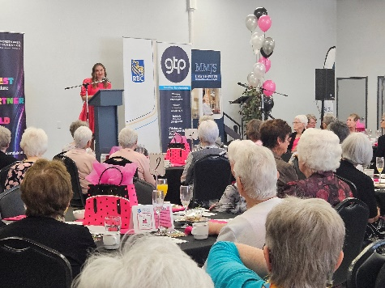
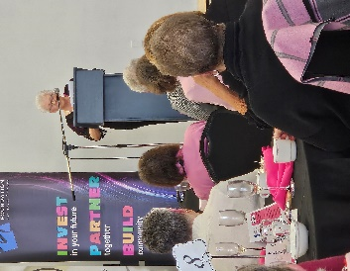
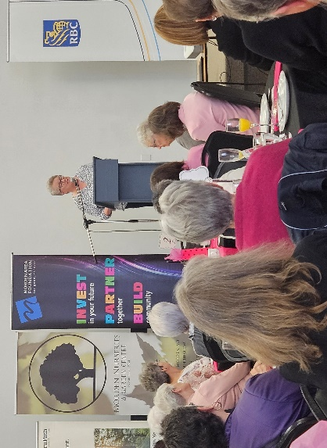
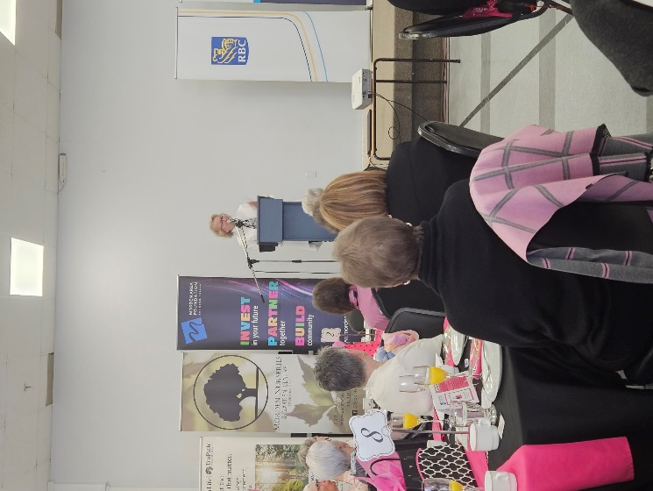
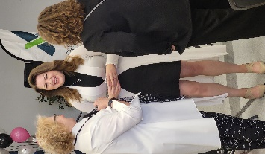
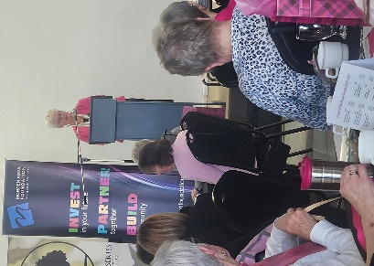
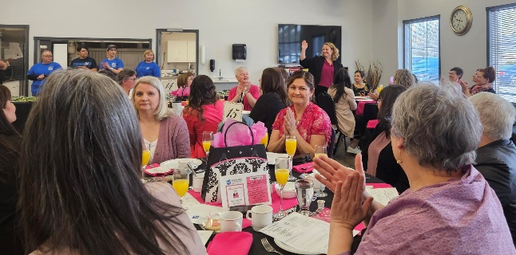
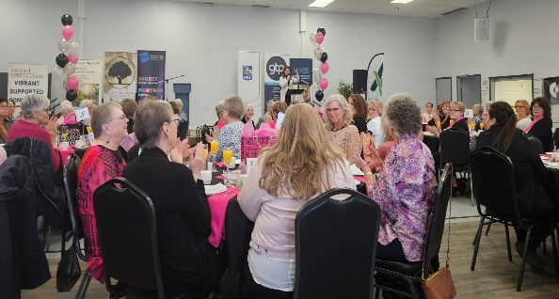

host
L & R Bursary
MFRC
YFC

Morden Area Foundation hosted another successful
Power of the Purse Brunch
Thanks to your support!

This year was amazing to experience women gathered in person on Saturday, April 6, 2024. 126 women participated, granting $12,600 in total to three presenting organizations.

According to the Charity of Choice cards submitted by participating ladies, the donor directed grants were made as follows:

Youth for Christ – $2,462 (Youth Community Garden Plots)
Morden Family Resource Centre - $2,253 (Lending Library for Families)
Learn & Return Healthcare Bursary - $7,885 (Bursary 2024)

Congratulations to these three excellent charities for their hard work within the community.

In nine years, the Power of the Purse Brunch event has granted out $97,449 to twenty six registered charities addressing various needs relating to women and children.

This brunch not only grants out a minimum of $10,000 each year to the community, but it also assists with building the Power of the Purse Endowment Fund with matching grant monies of $5,000 from the Morden Area Foundation. The Foundation also accepts gifts to this fund at any time during the year. The Fund’s current market value is $131,094.51. This fund will be able to continue to provide grants to projects for women and children should the brunch ever come to an end.

Thank you to the 2024 Power of the Purse Brunch event sponsors:
Access Credit Union, Menzies Medical Clinic, Dr. Randall & Karla Warkentin, Gislason Targownik Peters Chartered Professional Accountants, RBC, Focal Point Comprehensive Vision Care, MMJS Law Office, TruPath Financial Solutions, Morden Nurseries, Party on Rentals, and Linda & Sheri-Lynn Duncan.
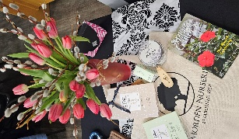
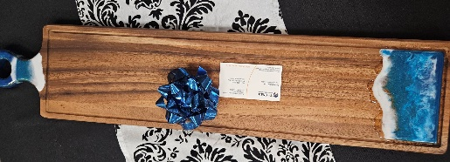
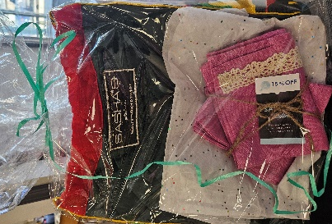
Thank you also to the door prizes sponsors:
Floral arrangement donated by Morden Nurseries
Charcuterie board - by TruPath Financial Solutions
A gift pack from Sasha’s Atelier

Thank you to our wonderful MC Jayme Giesbrecht and to Dave Destoop of Total Sound.

Without sponsorship and without your caring & thoughtful $100 gifts, the MAF and Power of the Purse Brunch committee would not have been able to raise and grant this amount of money to address various needs in Morden and area. Thank you very much for your participation this year and we hope to see you again next year’s Power of the Purse 10th year.

Planning Committee:

Sue Nelson, Monique Rampton, Nicole Walske, Tara Ritchie, Linda Knight, Zainab Zubair, Oleksandra (Sasha) Pashchenko and Lenore Laverty.



13 – 379 Stephen Street, Morden, MB R6M 0G8
Ph 204-822-5614 CP 431-349-1138
Email: info@mordenfoundation.ca

